Factoring
This is one of a series of review packets to refresh Algebra 1 topics for the Geometry student preparing to move on to Algebra 2. Examples, practice problems, and solutions are included.
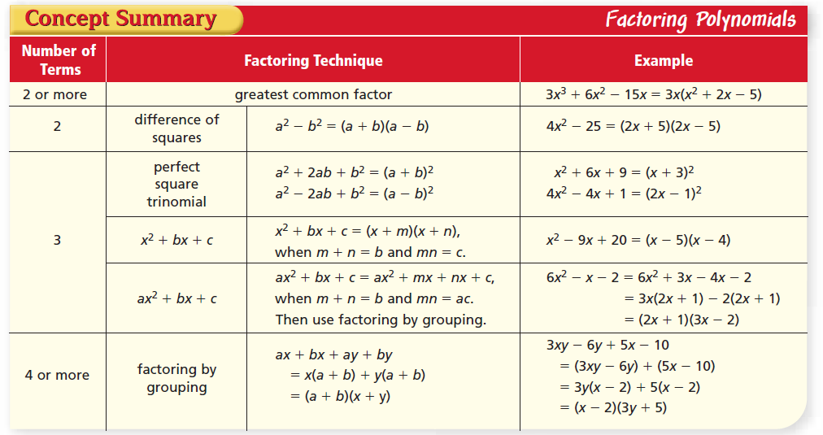

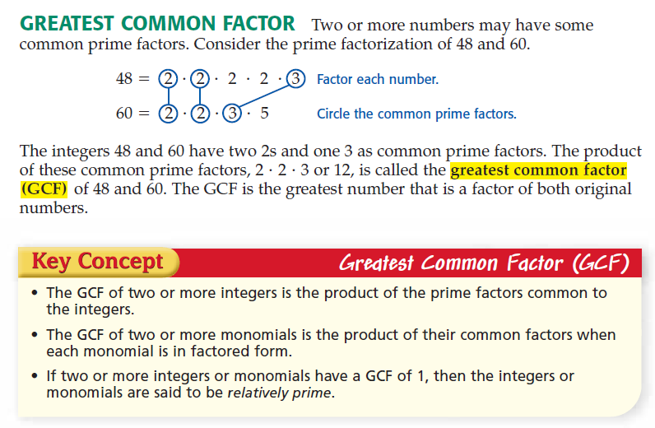
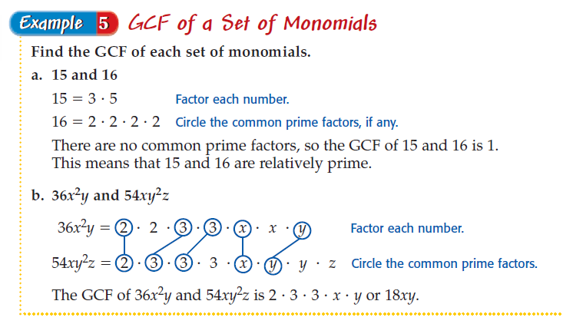
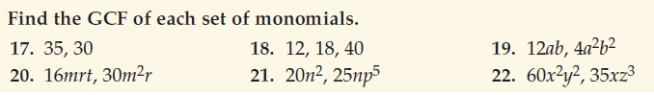
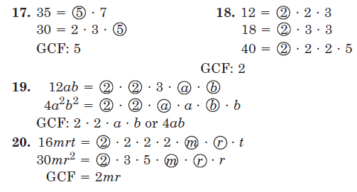
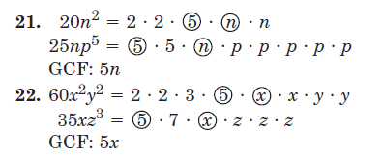
Factoring Trinomials – Reference Sheet
Example 1: Factor x² + 9x + 20
- Rewrite as 1x² + 9x + 20
- Multiply the coefficient of x² and the constant term 1 ∙ 20 = 20
- Find two values such that ___ ∙ ___ = 20 and ___ + ____ = 9
(notice that 9 is the coefficient of the x term)
- 4 ∙ 5 = 20 and 4 + 5 = 9
- Use the two values 4 and 5 for the next step.
- Set up the box that was used to multiply polynomials
The center term in the box is the first term in the trinomial.
The bottom right corner of the box is the last term of the trinomial.
The other two terms are the new values that were determined and are written as the coefficient of x. It doesn’t matter which way you place these two terms in these two boxes.
 | x² | 4x
 | 5x | 20

- Find the GCF of each row and column
 | x | 4
x | x² | 4x
5 | 5x | 20

- Identify the factors as (x+5)(x+4)
- Check your work by multiplying the factors.
If you get the original trinomial as your product, you know you have factored correctly.

Factoring Trinomials – Reference Sheet
The factors are not in order.
Example 2: Factor -4 – 3x + x²
- Rewrite as 1x² – 3x – 4
- Multiply the coefficient of x² and the constant term 1 ∙ -4 = -4
- Find two values such that ___ ∙ ___ = -4 and ___ + ____ = -3
(notice that -3 is the coefficient of the x term)
- 1 ∙ -4 = -4 and 1 + -4 = -3
- Use the two values 1 and -4 for the next step.
- Set up the box that was used to multiply polynomials
The center term in the box is the first term in the trinomial.
The bottom right corner of the box is the last term of the trinomial.
The other two terms are the new values that were determined and are written as the coefficient of x. It doesn’t matter which way you place these two terms in these two boxes.
 | x² | 1x
 | -4x | -4

- Find the GCF of each row and column
 | x | 1
x | x² | 1x
-4 | -4x | -4

- Identify the factors as (x – 4 )(x + 1)
- Check your work by multiplying the factors.
If you get the original trinomial as your product, you know you have factored correctly.

Factoring Trinomials – Reference Sheet
The coefficient of x² is not 1.
Example 3: Factor 2x² + 3x – 2
- Multiply the coefficient of x² and the constant term 2 ∙ -2 = -4
- Find two values such that ___ ∙ ___ = -4 and ___ + ___ = 3
(notice that 3 is the coefficient of the x term)
- -1 ∙ 4 = -4 and -1 + 4 = 3
- Use the two values -1 and 4 for the next step.
- Set up the box that was used to multiply polynomials
The center term in the box is the first term in the trinomial.
The bottom right corner of the box is the last term of the trinomial.
The other two terms are the new values that were determined and are written as the coefficient of x. It doesn’t matter which way you place these two terms in these two boxes.
 | 2x² | -1x
 | 4x | -2

- Find the GCF of each row and column
 | 2x | -1
x | 2x² | -1x
2 | 4x | -2

- Identify the factors as (2x – 1 )(x + 2)
- Check your work by multiplying the factors.
If you get the original trinomial as your product, you know you have factored correctly.

This trinomial has a GCF.
Factoring Trinomials – Reference Sheet
Example 4: Factor 8x² – 44x + 48
- Check to see if there is a common factor for all three terms.
If yes, factor it out. 4(2x² – 11x + 12)
- Multiply the coefficient of x² and the constant term 2 ∙ 12 = 24
- Find two values such that ___ ∙ ___ = 24 and ___ + ___ = -11
(notice that -11 is the coefficient of the remaining x term)
- -3 ∙ -8 = 24 and -3 + -8 = -11
- Use the two values -3 and -8 for the next step.
- Set up the box that was used to multiply polynomials
The center term in the box is the first term in the trinomial.
The bottom right corner of the box is the last term of the trinomial.
The other two terms are the new values that were determined and are written as the coefficient of x. It doesn’t matter which way you place these two terms in these two boxes.
 | 2x² | -3x
 | -8x | 12

- Find the GCF of each row and column
Note: although initially it doesn’t look like -4 is a common factor for -8 and +12 or that -3 is a common factor for -3 and +12, you have to arrange the negative factors so that you can multiply back to get what you started with. -3 ∙ -4 will = +12.
 | 2x | -3
x | 2x² | -3x
-4 | -8x | 12

- Identify the factors as (4)(2x – 3 )(x – 4)
Don’t forget to include the GCF you factored out in the first step!
- Check your work by multiplying the factors.
If you get the original trinomial as your product, you know you have factored correctly.
